School Times
Health and how to be healthy
Health is the most important part of our life.
It helps us to lead a comfortable life. It keeps us happy. Health is a precious gift.
Unluckily, not everyone can stay healthy. Some people destroy their health, and very often they don’t know or don’t think about that. Some people say they are healthy, but usually they are not. If you want to check your health, the medicine will help you. If you always want to be healthy, you should have your medical checkups regularly. Unfortunately, a lot of people don’t do it. The medicine can prevent you from being seriously ill. Actually, you can make or keep yourself healthy without medicine, but not completely and not always. To prevent diseases you should and shouldn’t do some things.
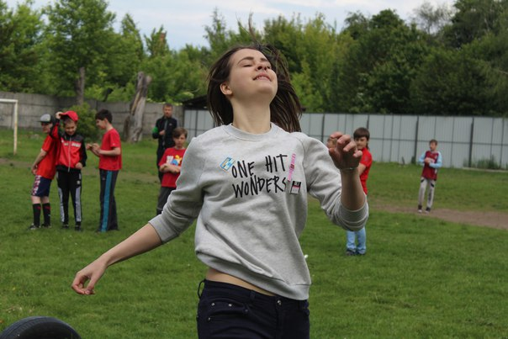
Things you shouldn’t do:
1. Smoking, drinking alcohol, using drugs
2. Eating unhealthy food
3. Have a sedentary lifestyle

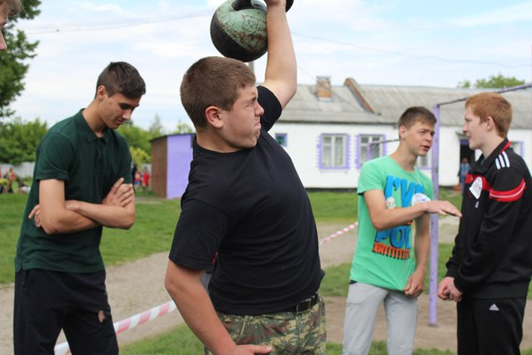
You can solve these problems by stopping them. The most effective thing, which will help you, is sport. Sport is almost a synonym to health. Sport isn’t just a hobby. Sport is a lifestyle. There are a lot ofdifferent kinds of sport: martial arts, heavy athletic, jogging, archery, gymnastic, fencing, yoga, equestrian sport, swimming and many other…
Also, sport will help you feel and look healthy. Sport isn’t a bad choice to be healthy.

If you only start to do sport and want to be healthy, you can start with this:
1. Do exercises in the morning
2. Go on PE lessons
3. You may even join sport section
4. Spend a lot of time outside

School symbols
Fastiv specialized school №4 still hasn’t any symbols. It’s really hard to differ our school from other. It’s a problem. Yes, our school is unique, but we need to prove it with the symbols, which our school does not have. We are up to creating school by ourselves. It can be a song, a logo, a mascot, a flag, etc. We encourage everybody to participate! Please send your ideas on our email: schooltimes4fastiv@gmail.com. The most interesting ideas will be chosen for further discussion.

Election of School President

Recently a new election of School President was announced. Only one student from each form of High School can take part in this election as a candidate. Posters, advertising, and many other ways to become a School President are allowed for the candidates. Teachers will take part in the election too (but not as candidates), so the election will be fair.
We all truly hope to find true leader of our school.
Good luck, candidates!
email: schooltimes4fastiv@gmail.com
Editor: Kiril M.
02.10.2016

