Матеріал, зібраний на цих сторінках, допоможе вчителям в проведенні уроків згідно діючих програм в 11 класі.
Добірка може бути використана, як роздатковий матеріал та на інтерактивній дошці.
Згідно Програми вчитель має можливість працювати над розвитком навичок читання, мовлення та письма
Я намагалась подати матеріал у форматі ЗНО, тому в модулях є вправи на використання мови, множинний вибір, тощо.
Тестові завдання мають ключі з відповідями.

Зміст
- Спорт. Олімпійські ігри. Видатні українські спортсмени.
- Освіта в Україні.
- Охорона навколишнього середовища.

Form 11
(Pastimes. Sports Competitions. The Olympic Games. Famous Ukrainian Sportsmen. Passive Voice)

The Olympic Games - Vocabulary
Word | Contextual Meaning
amateur | a person who does something without payment; not a professional
anthem | an important song (usually national)
banned | not allowed
broadcaster | a person who talks (often about sports and athletes) on television or radio
compete | to battle against another player
contestant | person who plays in a game
controversy | disagreement over an issue
doping | using illegal drugs in sport
facilities | buildings and places where events are held
fanfare | a piece of music that announces an important arrival
host | the country that holds the Games
humanity | all people
medal | a gold, silver, or bronze award given to a winner or runner up
motto | a personal belief that one shares, related to life
nationality | the country a person is from
oath | a promise
participant | someone who plays in a game
partisanship | unfair judging (usually for political reasons)
postpone | delay until later
preliminaries | tryouts
purity | total goodness
qualify | achieve the minimum requirement
representative | one person who speaks or acts on behalf of a team or group
security | people who control violence or rule-breaking and provide protection
spectator | a person who watches an event
sponsor(n) | a company that gives an athlete financial support in exchange for promoting clothes or other products
spokesman | a person (often an athlete) who represents a company in marketing or the media
sportsmanship | fairness and honesty in sports
stamina | having energy for a long time
standings | a record of athletes' performances
struggle | to work hard at something difficult
substitute | an extra team player used in emergencies
swifter | faster
symbol | an image that represents something
torch | a large flame on a stick
venue | the place where an event is held
victory | a win
2

Vocabulary - Winter Olympic Games

This is an illustrated list of vocabulary related to Winter Olympic Games
Alpine skiing | Biathlon | Bobsleigh
Cross Country | Curling | Figure Skating
Freestyle skiing | Ice Hockey | Luge
Nordic Combined | Short Track | Skeleton
Ski Jumping | Snowboard | Speed Skating

Text 1. Read the text and answer the questions below.

A sports event unlike any other
The Olympic Games are unique. Athletes from the entire world take part.
Their achievements are watched from both near and far by hundreds
of millions of spectators.
The five rings on the Olympic flag represent the international nature of the Games.
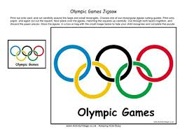. 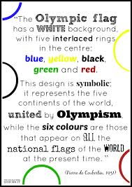
What makes the Olympic Games different from other sports events?
The Games are held every four years. They are the largest sporting celebration
in the number of sports on the programme, the number of athletes present
and the number of people from different nations gathered together at the same
time in the same place.
The Games are held at intervals, but are part of a broader framework which
is that of the Olympic Movement. The purpose of the Olympic Movement
is to promote the practice of sport all over the world. It is in this spirit that the Olympic Games are held and celebrated.
The Summer Games and the Winter Games
The Olympic Games include the Games of the Olympiad (i.e. the Summer
Games) and the Olympic Winter Games. The first edition of the modern
Summer Games was held in 1896 in Athens (Greece), and the first Olympic
Winter Games in 1924 in Chamonix (France).
The word Olympiad designates the four-year period that separates each
edition of the Summer Games.
Until 1992, the Summer and Winter Games were held in the same year,
but since then, the Winter Games were moved two years from the Summer
Games. The Summer and Winter Games continue to be organized once
every four years.
In the Summer Games, athletes compete in a wide variety of competitions
on the track, on the road, on grass, in the water, on the water, in the open
air and indoors, in a total of 28 sports.
The Winter Games feature 7 sports practised on snow and ice, both indoors
and outdoors.
The Modern Olympic Games
The London 2012 Olympic Games were broadcast all over the world, via the
traditional media as well as online and mobile platforms.
They reached a record audience estimated at 4.8 billion people.
It was Pierre de Coubertin of France who dreamt up this ambitious project,
although others before him had tried in vain to revive these Games. Drawing
inspiration from the ancient Olympic Games, he decided to create the modern
Olympic Games. With this purpose, he founded the International Olympic
Committee (IOC) in 1894 in Paris. The new committee set itself the objective
of organising the first Olympic Games of modern times.
The date of the first Games, 1896, marked the beginning of an extraordinary
adventure that has now lasted for over a century

- What represents the International nature of the Olympic Games?
- How often are the Olympic Games held?
- What is the purpose of the Olympic movement?
- Do the Summer and Winter Olympic Games take place in the same year?
- How many events are there in the Summer Olympiad?
- How many competitions are there in the Winter Olympic Games?
- Who founded the IOC?
Text 2. Read the text and answer the questions below.

The Paralympic Games is a major international multi-sport event, involving athletes with a range of physical disabilities, including impaired muscle power e.g. paraplegia and quadriplegia, muscular dystrophy, Post-polio syndrome, spina bifida), impaired passive range of movement, limb deficiency (e.g. amputation or dysmelia), leg length difference, short stature, hypertonia, ataxia, athetosis, vision pairment and intellectual impairment.
There are Winter and Summer Paralympic Games, which since the 1988 Summer Games in Seoul, South Korea, are held almost immediately following the respective Olympic Games. All Paralympic Games are governed by the International Paralympic Committee (IPC).
The Paralympics have grown from a small gathering of British World War II veterans in 1948 to become one of the largest international sporting events by the early 21st century. Paralympians strive for equal treatment with non-disabled Olympic athletes, but there is a large funding gap between Olympic and Paralympic athletes.
The Paralympic Games are organized in parallel with the Olympic Games, while the IOC-recognized Special Olympics World Games include athletes with intellectual disabilities, and the Deaflympics include deaf athletes.
These categories are further broken down into classifications, which vary from sport to sport.
- Who takes part in the Paralympic Games?
- When are the Paralympics held?
- When did the Paralympics begin?

Glossary:
physical disabilities /ˈfɪzɪkəl ˌdɪsəˈbɪlɪtiz / фізичні недоліки
paraplegia /ˌpærəˈpliːʤə / параліч кінцівок
quadriplegia - параліч чотирьох кінцівок
muscular dystrophy /ˈmʌskjʊlə ˈdɪstrəfi /
Post-polio syndrome / pəʊst ˈpəʊlɪəʊ ˈsɪndrəʊm / пост-поліо синдром
spina bifida спіна біфіда (хвороба хребта)
amputation ˌ /æmpjʊˈteɪʃ(ə)n/ ампутація
dysmelia - дісмелія
short stature /ʃɔːt ˈstæʧə / низький зріст
ataxia - порушення координації руху
athetosis- невимушений безперервний рух кінцівок
vision pairment ˈ/vɪʒən ˈpeəmənt / недоліки зору
intellectual impairmen /ˌɪntɪˈlɛktjʊəl/ інтелектуаліні вади

Best-known Ukrainian Sportsmen

Oleh Blokhin

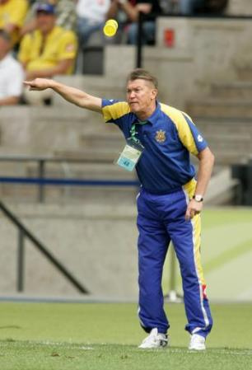
A legendary Ukrainian football player, USSR football champion in 1974, 1975, 1977, 1980, 1981, 1985, 1986, owner of “the Gold ball”, Super cup, two Cup of Cups, a forward. A chief coach of the National team of Ukraine from September 2003 till December 2008.

2. Serhiy Bubka
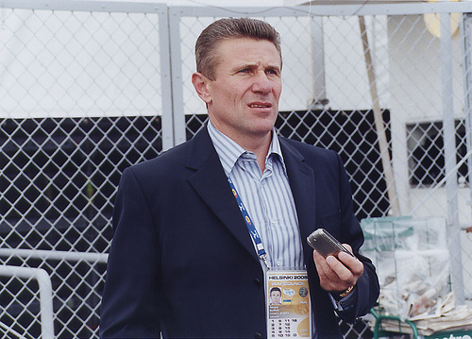
An outstanding Ukrainian pole vaulter who represented the Soviet Union until its breakdown in 1991. Having successively won 6 IAAF World Championships, he was fatally unlucky on the Olympics. Serhiy broke the world record in pole vaulting 35 times, cleared 6.0 metres first and is the only to have cleared 6.10 (as of March 2009). A really really cool guy, a successful businessman and a great patriot.

3. Vladimir Klichko
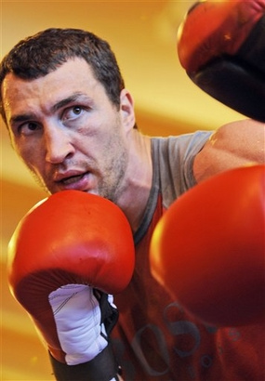
One of the great Klichko brothers, a professional heavyweight boxer since 1996, currently holds the IBF, WBO, IBO and Ring Magazine world heavyweight titles. Appeared in motion pictures and music videos, involved in charity projects, UNESCO activities. Unlike his big bro Vitaliy is still a sportsman.

Yana Klochkova

Yana Klochkova, (born August 7, 1982, Simferopol, Ukraine, U.S.S.R.), Ukrainian swimmer, who in 2004 became the first woman to win consecutive pairs of Olympic gold medals in the same events—the 200-metre and 400-metre individual medleys. Known as the “Medley Queen,” she lost only one medley race in international competition between 2000 and 2004.
Klochkova was born into an athletic family (both parents competed in track and field) and took up swimming at age seven. She began competing internationally in her mid-teens and took silver in the 400-metre individual medley at the world championships in early 1998. At the European championships the following year, she won both individual medleys in addition to placing third in the 400-metre freestyle event. At the 2000 Olympic Games in Sydney, Australia, she broke a world record in the 400-metre medley (4 min 33.59 sec). She followed up with an Olympic record in the 200-metre medley (2 min 10.68 sec) and concluded with a silver medal in the 800-metre freestyle (8 min 22.66 sec). Klochkova’s gold medals at the 2004 Olympic Games in Athens in the 200 metre (2 min 11.14 sec) and the 400 metre (4 min 34.83 sec) matched her performance at the previous Olympics.

Andrii Shevchenko

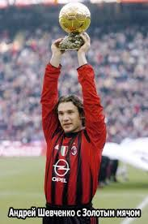
Everybody – football fans and non-football fans – knows Andrii Shevchenko or Sheva. He’s a real expert at scoring goals. At the end of his career in 2012, he was the third highest goal scorer in the Champions’ League ( the teams that play in the European Champions Cup). His story shows us that trying hard and not giving up is an important part of success. Andrii loved football when he was young and at eleven he tried to get into a specialized sports school in Kyiv. He failed the dribbling test, but luckily around this time Oleksandr Shpakov, a scout for Dynamo Kyiv, saw him playing. He asked Andrii to join the youth squad. At first Sheva played for Dynamo II and was their top goal scorer. Then he moved to the first team when he was eighteen and was a star player from the start.
His skill meant that foreign clubs wanted to buy him. In 1999 he went to Milan for a record $25 million. During the first season there, he scored 24 goals in 34 matches. But unfortunately, he was injured and took a long time to get fit again. However, he kept working and trying, and in 2004 he was back at the top and was named European Player of the Year. His move to Chelsea in 2006 was not so happy and the team loaned him back to Milan foe a couple of seasons. All through his career he continued to play for Ukraine and he is one of the most successful players of all time. He took part in 111 games for the national team and scored 48 goals.
He started his career at Dynamo where he was the youngest goal scorer. Then he finished his career at the same club as the oldest scorer.
Off the football pitch, Shevchenko uses his fame and football skills to help people in Ukraine. He set up the Andrii Shevchenko Foundation. This organization raises money to help orphanages. It also gives money to hospitals for equipment and to train doctors, social workers and psychologists.
He has a new life now without football boots, but the Foundation and helping others continues to be part of it.

Read the text and find the answers to the next questions.
- How many goals has A. Shevchenko scored for Ukraine?
- What does Andrii do when he isn’t successful at something?
- What stopped Andrii from continuing to score goals at Milan?
- When did Chelsea buy him?
- How does A. Shevchenko help people?

Popular Ukrainian Olympic Athletes
List of popular Ukrainian Olympic athletes, listed alphabetically with photos of the athletes when available. Famous Olympians from Ukraine have achieved some of the highest honors in sports and Olympic history, as even being chosen to represent your country at the Olympics is something that most athletes will never get to experience. These competitors are the most prominent people from Ukraine who have competed in the Olympics. Ukraine has a long, proud history of competing in the Olympic Games, and without these fierce athletes they never would have won any medals. The list you're viewing is made up of different items like Vita Iakymchuk and Lilia Vaygina-Efremova.

1.
Aljona Sawtschenko Figure skating
2
Andriy Kis Luge
3
Anton Kovalevski Figure skating
4.
Armen Vardanyan Greco-Roman wrestling
5.
Artur Ayvazian Shooting sports
6.
Enver Ablaiev Freestyle skiing
7.
8. Ganna Sorokina
9. Halyna Pundyk Fencing
10. Igor Razoronov Weightlifting
11.
Iryna Lishchynska Track and field athletics
12.
Irini Merleni Freestyle wrestling
13.
Kateryna Grygorenko Cross-country skiing
14.
Lesya Kalitovska Track cycling
15.
Lilia Efremova Biathlon
15.
Mikhail Gumenyak Cross-country skiing
16. 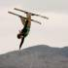
Nadiya Didenko Freestyle skiing
17.
Nataliya Dobrynska Track and field athletics
18.
Nataliya Tobias Track and field athletics
19.
Natalya Davydova Weightlifting
20.
Oksana Khvostenko Biathlon
21.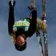
Oleksandr Abramenko Freestyle skiing
22.
Oleksandr Putsko Cross-country skiing
23.
Oleksandr Vorobiov Artistic gymnastics
24.
Oleksiy Torokhtiy Weightlifting
25.
Olena Antonova Track and field athletics

Grammar Corner.
Passive Voice be + Past Participle
Present Passive am, is, are + Past Participle (am/is/are done)
Past Passive was, were + Past Participle (was/ were done)
Exercises:
- Put the words in brackets in the Passive Voice.
- The first Olympic Games (hold) in Greece more than 2 000 years ago.
- The last Winter Olympiad (hold) in Sochi, Russia in 2014.
- The opening ceremony of the Olympic Games from the Fisht Olympic Stadium ( broadcast) all over the world.
- At the Closing Ceremony the Fisht Olympic Staduim ( transform) into a giant dance floor.
- The baton of the next Olympic Games ( pass) to the Korean hosts during the Closing Ceremony.
- Modern Summer, Winter Games and Paralympics (hold) every four years.
- The host country ( choose) by the IOC.

- Complete these sentences with an active verb. Then make these sentences passive.
- The Sports Institute ________ visits to places of interest.
- The local swimming pool ________ a free entry ticket to all students.
- Guides ________ groups into the hills on mountain bikes.
- The Hillside Centre ________ transport into the town.
- In the afternoons Action Sport _______ everyone to take part in a team sport.
- Action Sport ________ a different event every evening.
- Sports for All _______ lessons in swimming, diving or athletics.
- Sports for All _______ everyone to play football, hockey, rugby or tennis together.

(The key: 1.arranges, 2.gives, 3. take, 4.provides, 5, expects, 6.organises, 7.offers, 8. encourages)
Use of English.
- Read the text below and think of the word which best fits each space. Use only one word in each space. There is an example at the beginning.
Example: (0) their.
SPORTS TOURISM
Hundreds of thousands of fans travel worldwide to watch (0) their favourite sport –an international match, a tennis championship, a Formula One Grand Prix.

In recent years (1) ______ has been a huge increase in sports tourism. (2) ______ longer are people content to (3) ______ in an armchair to watch their teams or sporting stars on television. They want to be (4) ______ the action is, (5) ______ they pack their bags and head straight for the airport.

In (6) _____ to the usual sporting events, the Olympic Games are held (7) ______ four years. The Olympics may only last a couple of weeks, but (8) _____ affect the host city for several years before. New facilities (9) _____ to be built, not just for the Games themselves (10) ______ also for the thousands of international visitors (11) ______ come to stay. The effects are also felt outside the host city (12) _____ many visitors choose to explore the surrounding region, and this (13) _____ a lasting effect on tourism in the country. For example, (14) _____ the 1992 Olympic Games were held in Barcelona, in Spain, the city has (15) ______ an extremely popular tourist destination.
(The key: 1 there, 2 No, 3 sit, 4 where, 5 so, 6 addition, 7 every, 8 they, 9 have , 10 but, 11 who, 12 as, 13 has, 14 since, 15 become )
- Read the text below and decide which answer A,B , C or D best fits each space. There is an example at the beginning.
Example :
0 A years B rule C period D reign
THE EARLY DAYS OF FOOTBALL
Football became the game we know today during the (0) _____ of Queen Victoria in the nineteenth century. So many different (1) _____ of the game were being played in Britain at that time, that in 1863 the Football Association was (2) _____ in order to draw up and agree the (3) _____ of the game.
Throughout the country new football (4) ____ were built and the development of the railways (5) _____ that football teams and their (6) _____ could travel to the matches. In 1888 the Football League was ( 7) _____ up with twelve clubs, and football became a national sport, (8) _____ to rugby by many people as the more popular game of the (9) _____

Sometimes people played the game in just a field. In one town, Burnley, in the north of England, the field had a river (10) ____ along the side of it in which players (11)___ baths after matches. People stood on banks (12) ____ from earth and it was not until the early 1900s that (13) ____ stands were built. The players would have had two wooden (14) ____ for the goals with tapes across the top instead of a cross bar, and nets were not (15) ____ until 1891.

1. A methods B conditions C forms D ways
2. A formed B made C joined D offered
3. A techniques B laws C rules D lines
4. A grounds B places C lands D courses
5. A helped B intended C said D meant
6. A organizers B fans C partners D helpers
7. A put B got C set D made
8. A wanted B preferred C liked D favoured
9. A two B both C other D one
10. A lying B moving C running D causing
11. A got B took C ran D picked
12. A produced B made C consisted D worked
13. A accurate B right C proper D correct
14.A pins B nails C points D posts
15.A invented B composed C completed D presented

(The key:1C, 2 A,3 C,4 A,5 D, 6 B, 7 C, 8 B, 9 A,10 C,11 B,12 B,13 C, 14 D, 15 A)

Composed by Chepelianska G.O.

Knowledge is the facts, skills and understanding that you gain through learning and experience.

(Education in Ukraine, Prepositions,types of questions in Past Simple and Present Simple)

Match the proverbs and their equivalents in the Ukrainian language:

- Train hard fight easy. A) Вік живи – вік навчайся.
- To know everything is to know nothing. B) Ученому – світ, а невченому – тьма.
- As for me, all I know is that I know nothing. C) Важко в навчанні, легко в бою.
(Socrates)
- Learning is the eye of the mind. D) Знати все - це нічого не знати.
- Live and learn. E) Щодо мене, то я знаю тільки
те, що я нічого не знаю.

(Key: 1 C, 2 D, 3 E, 4 В, 5 A)

Vocabulary
Types of educational establishments
school | школа
nursery school | дитячий садок
primary school | початкова школа
secondary school | середня школа
state school | державна школа
private school або independent school | приватна школа
boarding school
sixth-form college
technical college
vocational college
art college
teacher training college
university | університет

School
Школа
classroom | клас
desk
blackboard | доска
whiteboard | дошка
chalk
marker pen або marker
pen
pencil
exercise book

lesson | урок
homework | домашня работа
test

term | семестр
half term
class

reading
writing
arithmetic
spelling
to read
to write
to spell
to teach

head teacher | Завуч\ директор
headmaster | завуч
headmistress | завуч
teacher | учитель
pupil | учень
head boy
head girl
prefect
school governor

register
assembly
break

school holidays
school meals
school dinners | шкільні обіди\сніданки

Facilities
 | computer room |  | комп’ютерний клас
 | cloakroom
 | changing room
 | gym (сокращенно отgymnasium)
 | playground
 | library |  | бібліотека
 | lecture hall
 | laboratory (часто використовується скорочено lab)
 | language lab скорочено від language laboratory)
 | hall of residence |  | гуртожиток
 | locker
 | playing field
 | sports hall

University
Університет
professor | професор
lecturer | лектор
researcher
research
undergraduate | студент
graduate | маючий вчений ступінь; випускник
post-graduate або post-graduate student | аспірант
Masters student
PhD student
Master's degree
Bachelor's degree
degree | ступінь
thesis
dissertation
lecture | лекція
debate

higher education
semester
student loan | Кредит на навчання
student union
tuition fees | плата за навчання
university campus

Other related words
exam (скорочено від examination) | екзамен
to sit an exam | здавати екзамен
essay или paper | эссе/робота
to fail an exam | провалити екзамен
to pass an exam | здати екзамен

to study | навчатись
to learn
to revise | повторювати
student | учень, студент
curriculum | навчальний план
course | курс
subject | предмет
grade | клас; амер. оцінка,
mark | оцінка
exam results | результати екзамена
qualification | кваліфікация
certificate | сертифікат
attendance

textbook

question
answer
mistake або error
right або correct
Wrong

BASIC VOCABULARY (15) : PREPOSITIONS
(FORMS, EXAMPLES, RELATED WORDS)
- according to
Then the students were split into five groups ~ their abilities.
→ accordingly (adv)
2. apart from
Well, ~ his long nose he is rather good-looking, isn't he?
- among
among other things
- She was ~ the few lucky people who managed to escape from the kidnappers.
- At the meeting they discussed, ~, recent developments in Eastern Europe.
- He was among the last to leave.
- on account of
All schools had to be closed temporarily ~ heavy snowfall.
= because of /
due to
- above all
above average
~, he has always acted like a real professional.
Last month's unemployment rate was once again significantly ~.
→ as mentioned
above
below average
- advise sb against
I strongly ~ you ~ giving any further information to the press.
→ (a piece of) advice (n)
- considering
You have done really well in your exams, ~ the difficult circumstances.
= in view of
concerned about
concerning
He has never been particularly ~ what other people think of him.
Police are trying to obtain information ~ his whereabouts.
→ a matter of concern (n)
= regarding (prep)
- beyond any doubt
beyond recognition
~, W. Shakespeare was the greatest writer of the sixteenth century.
He was amazed to see that the town centre had changed ~.
= undoubtedly
= one can hardly
- recognise it
by means of
The heavy load was lifted ~ of a large crane
→ means of transport
- in fact
Her primary school teacher assumed that she was a slow learner, whereas ~ she was partially deaf.
= actually (adv)
- in spite of
They went for a walk ~ the pouring rain.
= despite
13.instead
instead of
He didn't reply. ~, he turned on his heel and left the room.
With his driving license gone, he had to walk to work ~ going by car.
- to the best of my knowledge
I am not absolutely sure about when the project starts, but ~ it will be on June 16.
= as far as I know
15.unlike
Her latest novel is quite ~ her earlier works.
= different from

Make your own examples.

Reading

- Read the text and match the headings ( A-H) to the parts of the text ( 1-6). Two headings are not needed. Fill in the gaps with the words from the box.

elective exams primary extensive kindergarten subjects alphabet upper specialized private

Education in Ukraine

A. Compulsory education.
B. Extra-curricular activities.
C. School trips.
D. Teachers and students.
E. Pre-school years.
F. Types of schools.
G. Core curriculum.
H. Finishing school.

- __ In Ukraine most parents send their children to (1) ______ or nursery school at the age of three. Between the ages of three and six children develop social skills and learn to get on and play with each other. They also take their first steps in literacy and numeracy and are taught to count and to read the letters of the Ukrainian (2)______. They have lessons in art and craft and sometimes English.
- __ Compulsory education in Ukraine begins at the age of six when children start (3) ______ school ( grades 1-4). Then at the age of ten they go to basic or lower secondary school (grades 5-9) where they study until they are fifteen. Education is compulsory up to the end of grade 9. After this students can either continue their studies in (4) ______ secondary school (grades 10-11) or leave school and go to college or a vocational school
- __ Ukrainian students have a wide chice of (5) ______ . They study literature, mathematics, history, science, information technology, art, music and foreign languages. Students start to learn a foreign language – usually English, German or French – when they are in drade 1. Students who go to (6 ) ______ language schools also learn a foreign language from the first year of school but more extensively. Then they begin to learn a second foreign language in grade 5.
- __ Students in senior grades usually take ( 7) ______ courses in addition to their compulsory subjects. These are intended to prepare them for their future studies and to help them decide which profession to choose. After finishing grade 11 of upper secondary school, students can go into higher education. All applicants must take ( 8) _____ called the National Independent Tesing. The exams test students’ knowledge of core school subjects at the end of their school education.
- __ There are more than 20,000 schools in Ukraine and 95% of them are state schools. The other 5 % of Ukrainian schools are (9) ______ schools where parents pay for their children’s education. There are now more and more different types of schools such as gymnasiums, lyceums, language and specialized schools which offer ( 10) ______ learning in particular subjects, for example, foreign languages, information technology. Maths, law or art. In these schools students have access to interesting new subjects in addition to more traditional ones.
- __ Schools isn’t just hard work. It’s also about making friends and having fun. Some of the best learning experiences come from going on school trips and taking part in extra-curricular activities. There are clubs and activities covering a range of interests from literature to invironmental issues and science. Students can choose to do sport, join an art or drama club, have dance lessons or learn handicrafts such as embroidery, sewing or knitting. There is indeed something for everybody.

( The key : 1 E, 2A, 3 G, 4 H, 5 F, 6 B)
1 kindergarten 3 primary 5 subjects 7 elective 9 private
2 alphabet 4 upper 6 specialized 8 exams 10 extensive

- Read the text. Match choices (A-H) to (1-5). There are three choices you do not need to use.
Student Disinterest: Is It Curable?
Disinterested students – they are easy to spot. They come into class, drop their books, and sit at their desks. Indifference is written all over their faces – and all over the work they do. Most teachers are always seeking some ways to re-engage those disinterested students in the learning process.
The following are some fresh ideas to tackles the sticky problem of student disinterest.
- __ Work with what you’ve got. Group projects will meet those students’ need to be part of the group. Create projects that tap into their innate desire to make a difference in their world. Check out a few of the many Service Learning Web Resources available or connect learning themes to such social justice. This generation loves to interact. Capitalize on that by integrating online bulletin boards into your assignments. They’ll be busy writing that they won’t even realize they are learning.
- __ Enlist students’ opinions when possible. Provide plenty of opportunities for student choice in the way they learn and in the ways they are allowed to demonstrate what they know. That will encourage them to learn more.
- __ Create a bulletin board that shouts “Super Students”. Let students choose the work they are most proud of to display.
- __ Regularly provide rubrics at the beginning of an assignment, so students know what they have to do to achieve. Show that you want to help your students. Students will be encouraged to make an effort if they know you are willing to work with them.
- __ Consider publishing students’ work online. Nothing seems to motivate students quite as much as knowing that their work will have an extended audience. Encourage administrators to make a special effort to work with troublesome students. They can offer extra love and support.
- Make sure you meet your students’ learning expectations.
- Provide students with healthy food supplies.
- Turn learners’ weaknesses into strength.
- Reward students.
- Offer extra money for project work.
- Organize ‘no-disinterest’ campaign.
- Engage students in participation.
- Meet pupils’ emotional needs.

(The key: 1C, 2 G, 3 D, 4 A, 5H)

Writing.
Write questions to ask your parents about their schooldays. Use phrases from the box and your own ideas. Then write a short story based on their answers.
How old/ start school favourite subjects be good at study hard do sport go on school trips have many friends/ a strict teacher be late wear a uniform enjoy school

Grammar Corner
Types of Questions (Present Simple, Past Simple)
- Yes/ No question
Do you like your school? Yes, I do ( No, I don’t)
Does your friend go to the same school as you? (Yes, he does. No, he doesn’t)
Did your Dad go to the same school? (Yes, he did. No, he didn’t)
- Negative question
Don’t you go to school by bus? (Yes, I do. No, I don’t.)
Doesn’t he speak German fluently? (No, he doesn’t. Yes, he does.)
Didn’t your parents buy expensive textbooks? (Yes, they did. No, they didn’t.)
- Who /What question
Who taught you in the first grade? ( N. P. did)
Who teaches your younger brother now? (N.P. does)
What subjects does your brother like most of all? ( PT)
What school do you go to? (School No. 4)
- ‘Wh’ question
When do you leave home for school? ( 7. 30)
Where do you usually have your PT lessons? ( In the gym)
Why is he always late for school? ( He lives a long way from school)
Why did she come to school so late yesterday? ( She overslept)
- ‘or’ question
Do you study English or French at school ? (Both)
Does she sit with you or Natasha at school? ( With me)
Did your Mum like science or languages at school? ( She liked science more)
- Tag question
You walk to school, don’t you?
Your friends work hard at school, don’t they?
Your favourite teacher is strict, isn’t she?
You don’t make troubles at the lessons, do you?
He cheats at tests, doesn’t he?
You liked your first teacher, didn’t you?
You didn’t miss school much, did you?

Use of English
- Read the text below. Use the word given in capitals at the end of each line to form a word that fits the space in the same line.
There is an example at the beginning.
Example: ( o) foreigners
Going to school in West Africa
Africa has more languages than any other continent.
Although (0) _______ have been responsible for the FOREIGN
- ______ of some languages, there are hundreds INRODUCE
of local languages.

It is important that (2)______ for children begins in TEACH
the local language to avoid unnecessary (3) ______ CONFUSE
in West Africa, despite ( 4) ______ efforts , it is not GOVERN
always possible for every child to receive any ( 5 ) _____ EDUCATE
and for many families the fees for children to attend school
are very (6) ______ . However, although a family will usually EXPENSE
have to contribute towards the school fees, ( 7 ) ______ PAY
can be put off until the harvest is finished.

The (8) ______ small number of Africans reaching RELATIVE
university, therefore, find themselves in ( 9) ______ POSSESS
of a great deal of power and influence, as they are
always in a (10) ______ . MINOR

The key : ( 1 introduction , 2 teaching, 3 confusion, 4 government, 5 education, 6 expensive, 7 payment (s), 8 relatively, 9 possession,
10 minority)
- Read the text and look carefully at each line. Some of the line are correct, and some have a word which should not be there.
The first two lines are done for you.
- _Ѵ_ I am writing in response to an article which you printed
- was in your magazine last week and which was criticized young
01 ._ people like me. The article said that teenagers are rude and
02.__ noisy and not interested in other people. I think that comment
03.__ is very unfair and while then it may apply to some young people,
04.__it is certainly not true of me and my friends. For one example
05.__every Saturday morning we must work in our local community
06.__ by visiting elderly people in their own homes. Sometimes do they
07.__want help with their shopping, other times they ask to us
08 . __to do some work in their garden. We give up two or three hours
09.__ of our time and we don’t get paid. I also know by other friends at
10.__ school who help out in the local hospital once a week simply at
11.__ talking to patients who may not have any visitors, and even generally
12.__ just making themselves like useful in all sorts of ways. If we are noisy
13.__ it’s usually because we ‘re enjoying ourselves, and if we ever appear
14.__ rude, I can assure you it’s probably because we’re having chatting
15.__and laughing together, because you’re only young that once

(The key: 1 Ѵ,2 Ѵ,3 then, 4one, 5must ,6 do, 7 to, 8 Ѵ, 9 by, 10 at, 11 even, 12like, 13 Ѵ, 14having, 15 that)
Composed by Chepelianska G. O.

Earth Is Our Home.

Vocabulary and ideas to discuss the environment
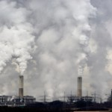

Environmental problems
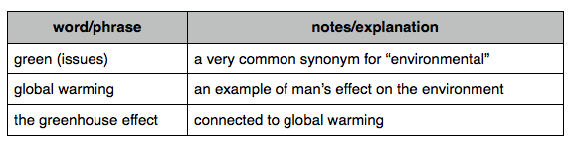
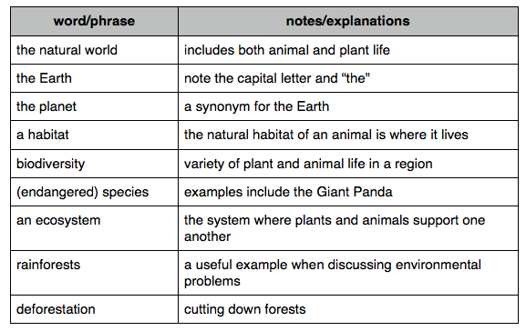

The natural world

Pollution
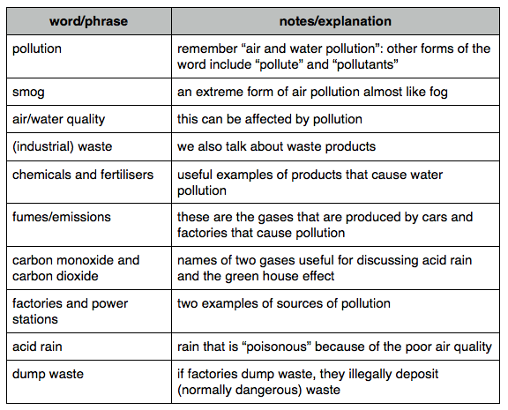

Energy
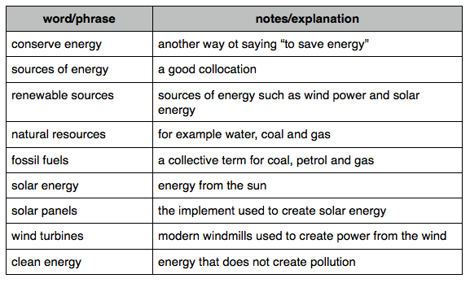
Useful verbs
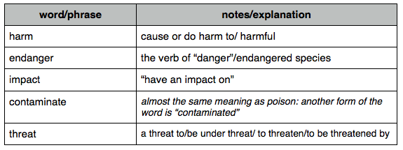

Speaking and discussion
- In pairs, ask and answer the following questions.
- What place on the Earth would you most like to be in and why?
- What kind of weather do you like and dislike?
- What do you do in that kind of weather?
- What kind of natural scenery do you like best? Why?
2) Match the words to make phrases.
1. Clear blue a) zero
2. Pouring b) climate
- Below c) winters
- Moderate d) skies
- Mild e) rain
(the key: 1d, 2 e, 3 a, 4 b, 5 c)
- Match the words that go together.
A). Air/water a) rubbish
B). Wind/water/solar b) effect
C). Sort c) warming
D). Global d) rain
E). Greenhouse e) petrol
F). Acid f) species
G). Unleaded g) pollution
H).. Animal h) power

The key: Ag, Bh, Ca, Dc, Eb, Fd, Ge,Hf)

Ideas to discuss the environment
The best way to learn vocabulary is in context, so in addition to useful list of words I have recorded 4 sample parts using some of the vocabulary. This way you can understand how to use it in practice.

The Ideas
In this section there are 4 speaking parts to listen and to read. The environmental vocabulary is highlighted.

Our Effect on the natural world
When we’re discussing the environment, it’s important not to forget that our actions have an impact not only on us but on the natural world and other species. So, for example, certain species are now endangered because of our actions. It’s not just because of hunting, but because we have destroyed their natural habitats. They do not have enough food or anywhere to live. If we carry on in this way, the biodiversity of the planet is under threat.:

Pollution
One of the most serious environmental problems today is of course pollution. It’s a very pressing green issue and if you travel to any of the large cities in China, for example, you’ll find that there is very bad air pollution and there is a layer of smog hanging over the cities. It’s just air pollution, but there is also water pollution in many parts of the world. The quality of the water is not good because rivers have been contaminated by all sorts of industrial wastes, by chemicals and fertilizers. And what we need to do is to recycle our waste and take care of the planet and try use renewable resources where we possibly can.

Energy
Another extremely important green issue is of course energy. There are two points to be made here. The first point is that the way we use energy is causing harm to the environment. Most of us get energy in the form of electricity. This electricity is produced by power stations. These power stations emit all sorts of dangerous gases such as carbon monoxide up into the atmosphere. And these gases cause acid rains which does harm to our ecosystem and environment. The second point to make about energy is we need to make sure that we are using energy in a sustainable way. There is a limit to the Earth’s natural resources and there is a danger that we use so much energy the Earth is no longer going to be able to provide us with sufficient coal and fossil fuels. What we need to do is look for more renewable sources of energy such as wind or perhaps solar energy from the sun.

Global Warming
What is the greatest threat to the Earth today? It’s probably a combination of global warming and the greenhouse effect. Our planet is slowly but steadily getting warmer, and one of the results is that the polar cap is melting and the levels of the ocean are rising. All this is caused by deforestation particularly of rainforests and particularly in the Amazon Basin. And this means that we may be doing irreparable harm to the planet and the future of the planet for our children and our children’s children looks rather bleak.

Questions for discussion:
- What is the ecological situation in the place where you live?
- How do you and the people around you contribute to the situation?
- Are any measures taken to improve the ecological situation in your place?
- Do you often discuss environmental issues in your family or at your school?

How Much Do You Know about Elephants?
Choose the correct word or words in these sentences, then decide whether the sentences are true or false.
- The elephant has the longer/ longest nose (or trunk) in the animal kingdom. T/F
- The elephant does much/ more with its nose than/that any other animal. T/F
- There are most / more than of 40 000 muscles in an elephant trunk. T/F
- Elephants have worse / worser memories than most animals. T/F
- An elephant can run more fast/faster than a human being. T/F
- The mammoth was as big/ no bigger than the present day elephant. T/F
- Elephants are the largest/most large land animals. T/F
- Elephants can be trained more easily/ easier than any other animal. T/F
- The Asian elephants’ ears are just as bigger/big as/than the African
elephant’s T/F
- An elephant eats as more/ much as 225 kilos a day. T/F

The key:
- longest; 2. more, than; 3.more , than; 4.worse; 5.faster; 6. no bigger; 7. largest; 8. more easily; 9. big, as;
much;
The answers:
- True.
- True. An elephant does all of the following with its trunk: smells; breathes; sprays water (or sand) over its body; puts its food in its mouth; blows trumpet calls, pulls down trees, detects insects in the air and carries heavy objects)
- True.
- False. They have good memories; if you attack them, they won’t forget it.
- False. The world record for a human runner is 43.37 km per hour. The top speed of an elephant is 40km per hour.
- True. It was about the size of an African elephant.
- True.
- False. Dolphins and primates are easier to train.
- False. They are smaller.
- True.

Reading.
Read the text and choose correct options( A, B, C or D).
GROCERY STORE BANS PLASTIC BAGS
Many people are asked “Paper or plastic?” when their groceries are being bagged in the supermarket. Soon one grocery store won’t be asking shoppers that question. The store is eliminating plastic bags to (1) ____ on the amount of trash in the environment.
The owners of Whole Foods Market said in January that they will no (2) ____ use disposable plastic bags after Earth Day 2008, which is 22 April. They hope shoppers will bring their (3 ) ____ reusable bags. If shoppers don’t bring their own bags, the store will (4) ____ paper bags made from recycled paper.
The store’s (5) ____ to end use of plastic bags is its gift to the planet this Earth Day, said A.C. Gallo. Whole Foods’ president. “We estimate we will (6) ____ 100 million new plastic grocery bags out of our environment between Earth Day and the end of this year”, he said.
Scientists say that plastic bags are bad (7) ____ the environment because they (8)____ drains, harm wildlife, and (9)____ too much space in landfills.
Some countries have (10) ____ plastic bags and others tax people who use them. Last year, San Francisco, California, became the first US city to forbid disposable plastic bags (11) ____ stores.
Some people say we should stop ‘trashing’ plastic bags. Plastic bags are (12) ____ and take less energy to produce than paper bags, they say. Plus, they can be used over and over.

A B C D
1. cut in cut off cut down cut for
2. greater further farther longer
3. own private individual peculiar
4. suggest offer propose nominate
5. dream ambition plan scale
6. show bring put keep
7. against on for off
8. seal clog tie hinder
9. take up take down take after take off
10.closed banned restricted shut
11.of from off on
12.cheap cheaper cheapest costly

(The key: 1. C, 2.D, 3.A 4.B, 5.C, 6.D, 7.C, 8.B, 9. A,10.B, 11.B, 12.B)

Use of English.
Read the following text about an interesting way to measure the temperature. For gaps 1-9 choose the correct option A-D
NATURE’S THERMOMETER
According to reliable sources (1) ____ The Old Farmer’s Almanac, we can measure outdoor temperature without the help of a traditional thermometer.
(2)____ you need is good ears, a bit of countryside and silence. Your natural thermometer will be nothing (3)____ a small green insect: a cricket. We all listen to the concerts these animals give on warm summer evenings, but what (4)____ this have to do with the temperature?
Crickets chirp as they rub their legs or wings together. That is, male crickets (5) ____. Although we often find their music relaxing, it is not (6)____ to be that. The sound is a cricket’s way to serenade his lady and to keep other males as far as possible. In 1897 physicist Amos Dolbear suggested that counting the chirps of the cricket’s will tell us (7)___ temperature is.
There are various formulas for making one’s calculations. If you understand Celsius, rather than Fahrenheit, you need (8)____ the number of chirps in 25 seconds, divide it by 3 and then add 4 to get the current temperature. But do remember – you will only be able to find out the temperature in this way when (9)____ crickets around. Below 15°C you may not have many of them. Or if they are there, they will probably not be in the mood for love.
1. A similar B like C alike D for
2. A All B And C Which D --
3. A and B but C then D because
4. A is B does C did D do
5. A were B did C are D do
6. A intended B intend C intends D to intend
7. A how much B which C what D how high
8. A counter B counted C to count D counting
9. A they are B there are C are D --

(The key: 1.B, 2.A, 3. B, 4.B, 5. D, 6. A, 7. C, 8. C, 9. B)
Composed by Chepelianska G.O.

